Yashkumar Patel

Q1a:

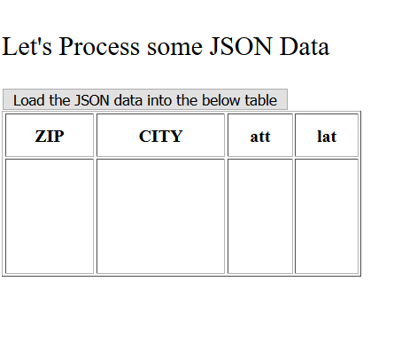

Q1b:

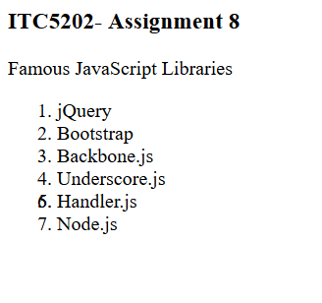

Q1c:

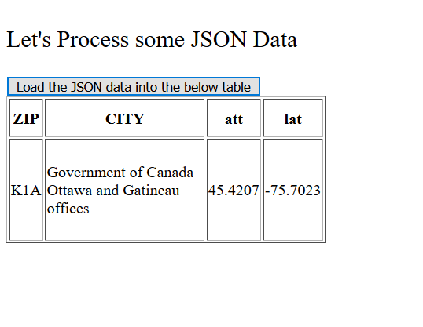

Q2:

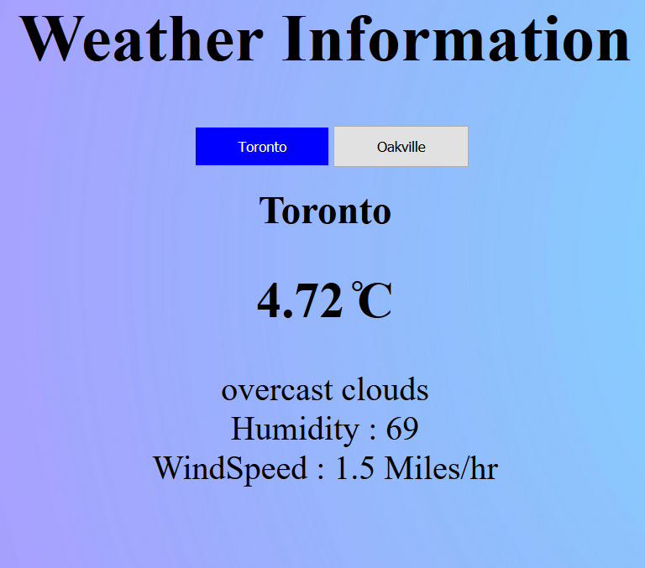

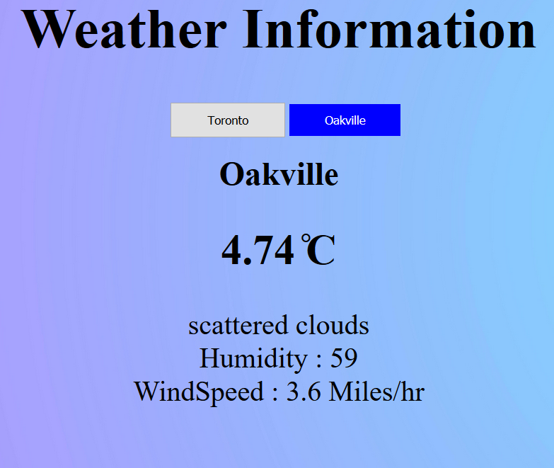

Q3:

$.each() is similar to foreach loop it uses index to traverse through list of data and access data using index. We can also use key value pair to access data in loop.

Syntax:

$.each(data,function(i){

Alert(‘data[i]’);

})

Or

$.each(data,function(key,value){

Alert(‘key+value’);

})

